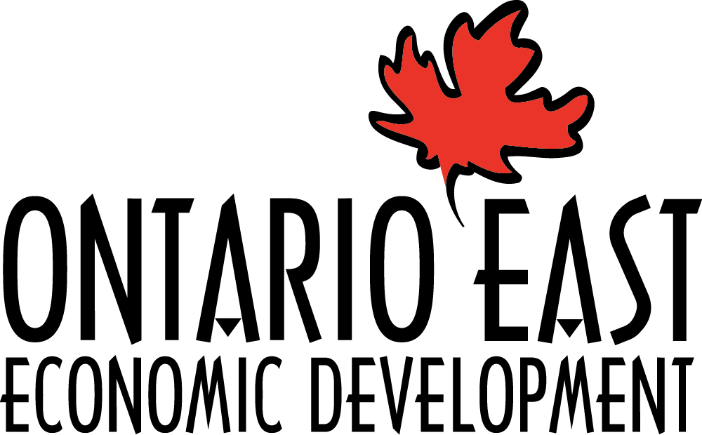

ECONOMIC DEVELOPER OF THE YEAR
(EDO of the Year)

Nominations are now open!

Ontario East Economic Development is seeking nominations to recognize an economic development practitioner in Eastern Ontario as the Economic Developer of the Year at the Ontario East Municipal Conference (OEMC) to be held in Ottawa, Ontario on September 6-8, 2023.

Nominations are open to all Active and Associate Members of the Ontario East Economic Development Commission. If you wish to nominate an individual, see the following nomination form to be completed and sent to Ontario East Economic Development by the deadline of 4:00 p.m. Friday, August 11th, 2023.

For more information please contact, Lucy Medeiros,
Program Administrator, Ontario East Economic Development Commission at lucy@ontarioeast.ca or by calling 613-634-8569.
EDO OF THE YEAR AWARD – Nomination Form

Name of Nominee:

Title:

Municipality/Organization:

Nominee’s Contact Information

Phone Number: Email:

Is the nominee or their community a member of Ontario East Economic Development Commission?
Yes ___ No ___ Not sure ___

Size of Organization (if available)
Annual budget ________________
Staff (full time) ________________
Staff (part time) ________________

Name of the Nominator:

Contact information for the Nominator

Phone Number: Email:

The award will honour an Ontario East Member who has made a significant contribution to one or more areas of economic development: (please, check which apply to your nominee!)

Recognition for their contribution to professional development in economic development;
Development and or implementation of a new program(s), project(s) or strategy(s) in economic development in eastern Ontario;
Developed or implemented a marketing promotion benefiting eastern Ontario;
Demonstrated or organized an activity, program, or public education event highlighting or enhancing the role of economic development in eastern Ontario or the Ontario East Economic Development Commission.

Please answer the following questions. Please attach additional pages if necessary.
Describe the nominee’s role in the development of new programs, strategies or achievements in economic development. Please include details of their role in the development or implementation.

Provide information on the nominee's contribution to educational programs in economic development and how they enhance the profession.

During this past year, has there been a project in the community (or region) that the nominee has spearheaded or played a major role in? Below is a list, to assist you in completing the application to show the depth of the project or campaign.

a) Media Coverage
b) Marketing or communication initiatives
c) Published articles (attach as an addendum or include link)

d) Other

Please describe other contributions of the nominee in the development of programs, initiatives and/or activities for the benefit of Eastern Ontario.

How many years has the nominee been active in the economic development profession?

Why do you believe this nominee should be chosen?

Signature of Nominator: __________________________________

Date:

Deadline for submission: Friday, August 11th, 2023, at 4:00 p.m.

Send to:
info@ontarioeast.ca

