EMPLOYMENT OPPORTUNITY
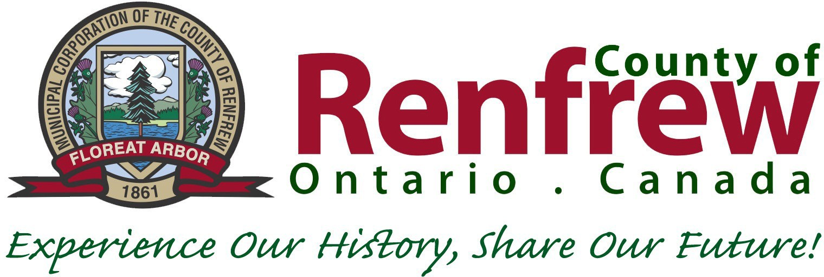

Manager of Economic Development
Full Time - Permanent

Renfrew County is located in the heart of the Ottawa Valley. The area is rural in nature and is made up of distinct regions, offering a range of living styles, outdoor adventures and a welcoming community. This could be your opportunity to live life to the fullest. The County of Renfrew offers exciting opportunities to contribute and grow, in a collaborative environment.

Reporting to the Director of Development & Property, the Manager of Economic Development is responsible for a full range of activities relating to the Economic Development Division. The Manager will provide professional economic development advice and assistant to business owners, site selectors, consultants and the municipalities in the County on matters relating to local business attraction, retention and expansion. The Manager will conduct research and provide information on government and private sector programs and services to local businesses and lower-tier municipalities.

Qualifications:
- Post-secondary education in a field related to economic development, marketing, tourism development, business/entrepreneurship, and domestic/international business management.
- 5-6 years’ progressive experience dealing with municipal, provincial, and federal government agencies, academic and educational institutions, a wide range of businesses, services and manufacturers in multiple sectors.
- Computer fluency required with Internet-based research, work processing, spreadsheets, databases, presentations, and graphics software.
- Excellent interpersonal, communication, presentation, marketing and analytical skills are essential.
- Entrepreneurial with proven strategic planning, risk analysis and administration experience.
- Experience in governmental proposal writing and reporting.
- CMMIII, CMO, Ec.D., CITP certification an asset.
- Supervisory experience essential.
- Valid drivers’ license and immediate accessible transportation required.

Compensation: $83,985 - $95,841 per annum, plus comprehensive benefits package.

Please send your resume, stating Competition #22-90 by 4:00 p.m., Tuesday, May 24, 2022 to:
Human Resources, County of Renfrew
9 International Drive, Pembroke, ON K8A 6W5
EMAIL: hrinfo@countyofrenfrew.on.ca (in MS Word or pdf format)

Thank you for your interest, however, only applicants considered for an interview will be contacted. Accessibility accommodations are available for all parts of the selection process. Applicants must make their needs known in advance. Information collected will be handled in accordance with the Municipal Freedom of Information and Protection of Privacy Act.

